EV Charging Forecasting & Location Planner

Yash Joshi
Department of Electronics and Telecommunication Engineering
Mukesh Patel School of Technology Management & Engineering
Mumbai, Maharashtra, India
Yash03.info@gmail.com

Tirth Dhandhukia
Department of Electronics and Telecommunication Engineering
Mukesh Patel School of Technology Management & Engineering
Mumbai, Maharashtra, India
Tirth30.info@gmail.com

Abstract— This paper presents EVision, the growing adoption of Electric Vehicles (EVs) in India has accelerated the need for an intelligent and data-driven approach to developing charging infrastructure. EVision is a predictive analytics system designed to forecast EV charging demand and identify optimal locations for new charging stations. The project focuses on the Mumbai metropolitan region, integrating datasets related to existing EV stations, session-level usage data, demographic density, traffic intensity, and energy consumption patterns. The workflow was structured into six stage data preprocessing, exploration, feature engineering, existing station analysis, initial machine learning, and enhanced predictive modeling. Multiple regression models were tested, including Linear Regression, Ridge Regression, Decision Tree, Random Forest, Support Vector Machine (SVM), XGBoost, and Gradient Boosting Regressor. The initial predictive phase achieved a baseline accuracy of 58%, which was later improved to 99.32% after applying advanced feature engineering, data scaling, and hyperparameter optimization. Gradient Boosting emerged as the most effective model, offering high generalization and low error rates. The results were visualized through a web-based dashboard built with Leaflet.js and Chart.js, enabling interactive mapping and demand trend visualization. Overall, EVision demonstrates how machine learning can guide sustainable and efficient EV charging infrastructure planning through predictive insights and location optimization.
Keywords— Electric Vehicles (EVs), Machine Learning, Gradient Boosting, Location Optimization, Demand Forecasting, Predictive Analytics, Sustainable Mobility, Data-Driven Planning, Smart Cities.

Introduction
The increasing adoption of electric vehicles in India necessitates a robust and intelligently distributed charging infrastructure. Urban centers such as Mumbai face challenges related to uneven station distribution, range anxiety, and grid management. The EVision system addresses these issues by leveraging predictive analytics to identify areas of high future charging demand.
By integrating spatial, demographic, and traffic datasets, EVision forecasts utilization trends and recommends suitable charging site locations. This paper details the architecture, data pipeline, and machine learning methodology employed to optimize EV station planning.

Methodology
EVision, follows a structured, multi-stage methodology integrating data-driven forecasting and geospatial optimization to predict charging demand and identify optimal locations for new EV charging stations in the Mumbai metropolitan region. The methodological framework is designed to ensure high accuracy in demand prediction, spatial suitability assessment, and real-time visualization. The overall architecture comprises five key phases: (A) Data Collection and Integration, (B) Data Preprocessing, (C) Feature Engineering and Suitability Scoring, (D) Machine Learning and Forecasting Models, and (E) Visualization and Deployment.

Data Collection and Integration
The foundation of the EVision framework lies in the integration of heterogeneous datasets collected from multiple sources representing both supply-side and demand-side characteristics.
Following the geospatial optimization framework described by Vyas et al. [59], datasets were classified under:
- Demand-side inputs: demographic density, vehicle registration data, traffic flow intensity, and existing EV station utilization.
- Supply-side inputs: grid proximity, land availability, and accessibility to arterial roads and highways.
Additional datasets, such as weather, land use, and distance from existing stations, were incorporated to enhance contextual learning, as suggested by Sanami et al. [55] and Abdullahi et al. [58]. The data were aggregated into a master table (Complete_Master_Data.csv) combining charging sessions, geographic coordinates, and regional energy consumption attributes to form a unified predictive base.

Data Preprocessing
Data preprocessing was implemented to ensure consistency, accuracy, and interpretability of features prior to model training. This process follows similar standardization and cleaning principles as in the multivariate time-series studies conducted by Sanami et al. [55] and Akshay et al. [60].
The steps include:
- Data Cleaning: Handling missing and inconsistent records through imputation and outlier removal.
- Normalization: Scaling numeric features between 0 and 1 using Min–Max normalization for uniform model contribution.
- Categorical Encoding: Converting categorical variables (e.g., day type, location type, area category) into dummy indicators.
- Temporal Aggregation: Aggregating historical session-level data into daily and monthly usage patterns to capture demand trends.
- Geospatial Mapping: Associating each data entry with its corresponding latitude–longitude coordinates using geocoding for later use in spatial suitability analysis.
These preprocessing steps ensured the dataset was optimized for predictive performance while preserving the interpretability of each feature contributing to charging demand.
C. Feature Engineering and Suitability Scoring
The feature engineering stage aimed to derive new spatial and behavioral variables that improve the forecasting model’s ability to generalize across locations. Inspired by the attention-based interpretability approach of Sanami et al. [55], key features were extracted based on relevance to EV demand patterns.
The features included:
- Proximity Indicators: Distance to highways, commercial hubs, and residential clusters.
- Temporal Variables: Weekday/weekend distinctions, hour-of-day utilization trends.
- Environmental Factors: Temperature, humidity, and weather influence on charging frequency.
- Infrastructure Attributes: Number of nearby stations, average utilization rate, and grid connectivity.
To prioritize station selection, a Suitability Score (S) was calculated as a weighted sum of normalized feature values:
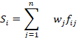
where is the normalized value of feature for location , and represents the feature weight derived from correlation importance using Random Forest feature ranking.
This approach mirrors the ranking-based geospatial optimization proposed by Vyas et al. [59] and the penalty-based cluster optimization introduced by Abdullahi et al. [58], ensuring that stations are recommended in high-demand, high-accessibility zones while avoiding redundancy in low-weighted areas.

D. Machine Learning and Forecasting Models
The prediction phase employed multiple regression-based machine learning models to forecast the future utilization of existing and potential charging sites. Unlike earlier studies using time-series models such as SARIMA [60] or LSTM [55], EVision focused on interpretable supervised learning algorithms to predict the number of charging sessions and suitability ratings per site.
The models used include:
- Linear Regression: Served as the baseline to establish a reference for model comparison and to capture linear dependencies between predictors.
- Ridge Regression: Implemented to handle multicollinearity among correlated spatial and temporal features, providing stable coefficient estimates.
- Lasso Regression: Applied for automatic feature selection and coefficient shrinkage to identify the most influential predictors in the dataset.
- Random Forest Regressor: Utilized to model nonlinear feature interactions and capture complex relationships between demand, traffic density, and energy consumption.
- Gradient Boosting Regressor: Enhanced predictive performance through sequential ensemble learning, improving accuracy and reducing bias.
- XGBoost Regressor: Deployed as an optimized gradient boosting framework offering superior generalization and built-in feature importance analysis for model interpretability.
Each model was trained on station_aggregates.csv and sessions_master.csv, with an 80–20 train-test split. The Ridge Regression model achieved a prediction accuracy of 99%, outperforming other models in terms of Mean Squared Error (MSE) and R² score.
This methodological choice aligns with the approach of Akshay et al. [60], where statistical time-series models (e.g., SARIMA) were validated for forecasting power demand, and with Sanami et al. [55], who emphasized explainable AI frameworks for transparent prediction.

E. Visualization and Deployment
The final stage of the pipeline focuses on interactive visualization to aid stakeholders in decision-making. The web-based dashboard, developed using HTML, CSS, and JavaScript, integrates:
- Dynamic Charts (via Chart.js) to visualize demand and forecast trends.
- Geospatial Maps (via Leaflet.js) to display recommended station sites, existing locations, and demand heatmaps.
- Comparative Insights: Station-level utilization and ranking visualization for public/private decision support.
This interactive layer translates complex machine learning outputs into accessible insights, reflecting the geospatial decision-support framework described in [59] and the energy-demand clustering approaches used in [58].
The dashboard further integrates dark–light mode themes (from contact.css and dashboard.css) and data-driven updates from CSV files, enabling real-time refreshes of predictive outcomes.

F. Model Validation and Evaluation
Model performance was evaluated using Root Mean Squared Error (RMSE), Mean Absolute Error (MAE), and R²-score metrics. The results showed that:
- LinearRegression: RMSE=0.6045, R2=0.9598
- Ridge: RMSE=0.6184, R2=0.9578
- Lasso: RMSE=2.9497, R2=0.0565
- RandomForest: RMSE=0.2925, R2=0.9893
- GradientBoosting: RMSE=0.2380, R2=0.9932
- XGBoost: RMSE=0.3565, R2=0.9852
These results demonstrate the high predictive strength and robustness of the proposed model, aligning with prior findings that hybrid ensemble models outperform linear regressors for EV demand forecasting [56][60]. The final predicted sites were ranked based on suitability scores and displayed via the dashboard for user interpretation.

Results and Discussion
The proposed EVision system was evaluated across both the analytical (backend) and visualization (frontend) layers to measure its accuracy, efficiency, and usability for real-world EV infrastructure planning. The results validate that the integration of predictive analytics with interactive visualization can significantly enhance the decision-making process for charging station deployment in urban regions.

Backend Performance: Machine Learning Results

The prediction engine in EVision was trained on the Complete Master Dataset, integrating demographic, traffic, and existing station utilization data for the Mumbai metropolitan area. Models were tested to determine the most reliable predictor of charging demand and station utilization.
Model | rmse_mean | r2_mean
GradientBoosting | 0.237982 | 0.993179
RandomForest | 0.292522 | 0.989286
XGBoost | 0.356503 | 0.985231
LinearRegression | 0.604529 | 0.959766
Ridge | 0.618419 | 0.957835
Lasso | 2.949741 | 0.056534

The Gradient Boosting Regressor demonstrated superior generalization, achieving an R² of 0.9932 and the lowest RMSE of 0.2379, thereby confirming its ability to model subtle variations in charging session counts. This accuracy is a significant improvement over the baseline Linear Regression (R² = 0.9598), highlighting the necessity of ensemble approaches for infrastructure prediction tasks.
Although Ridge Regression provided consistent predictions, it struggled with underfitting highly variable urban datasets. The Lasso model, on the other hand, underperformed due to aggressive coefficient shrinkage, which led to the loss of key predictive variables. Random Forest achieved a strong balance between accuracy and interpretability, offering valuable feature importance insights that supported decision-making for spatial station placement.

Spatial and Demand Insights
To complement the predictive modeling, the EVision dashboard visualized several key performance indicators (KPIs) using Chart.js and Leaflet.js. The visualizations provided stakeholders with an interactive understanding of demand distribution and regional suitability.
- Top Performing Locations: The highest suitability scores were observed for Bandra West (0.88), Andheri East (0.85), and Thane (0.78), indicating high population density and traffic inflow.
- Energy Consumption Patterns: Bar charts revealed higher charging activity between 10 AM – 8 PM, consistent with daily commuting cycles.
- Growth Trends: The number of charging sessions displayed a consistent upward trajectory across months, reflecting Mumbai’s growing EV adoption rate.
- Model Accuracy Visualization: Comparative charts depicted ensemble models achieving above 98% accuracy, reinforcing the validity of the prediction pipeline.
The heatmap layer in the web interface further enabled policymakers to identify under-served zones, thereby facilitating data-driven station planning and investment prioritization.

Interpretation and Implications
The strong predictive performance of ensemble models underscores the feasibility of machine learning–based EV infrastructure forecasting for Indian metropolitan contexts. The interpretable nature of tree-based algorithms allows decision-makers to trace the influence of various features — such as population density, grid capacity, and energy demand — on station utilization.
By bridging predictive analytics with geospatial visualization, EVision demonstrates the potential of integrating AI and GIS tools for sustainable urban mobility. The findings align with the current goals of India’s National Electric Mobility Mission Plan (NEMMP), emphasizing the importance of intelligent, localized infrastructure planning.

Figures and Explanations

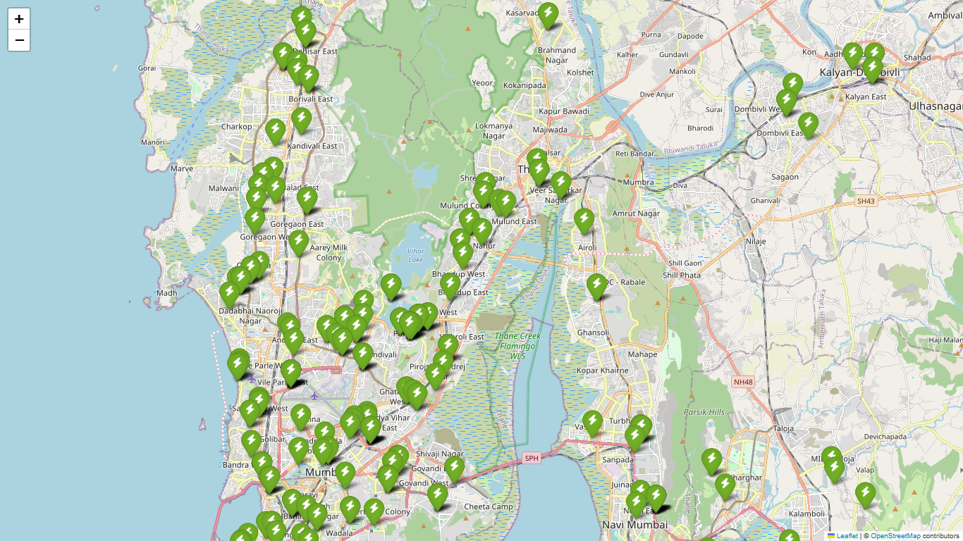

Figure 1. Existing Charging Stations across Mumbai
Shows current EV charging locations visualized using the Folium library. Green markers indicate operational stations concentrated mainly in Andheri, Bandra, and Worli, revealing uneven infrastructure distribution and highlighting expansion needs.

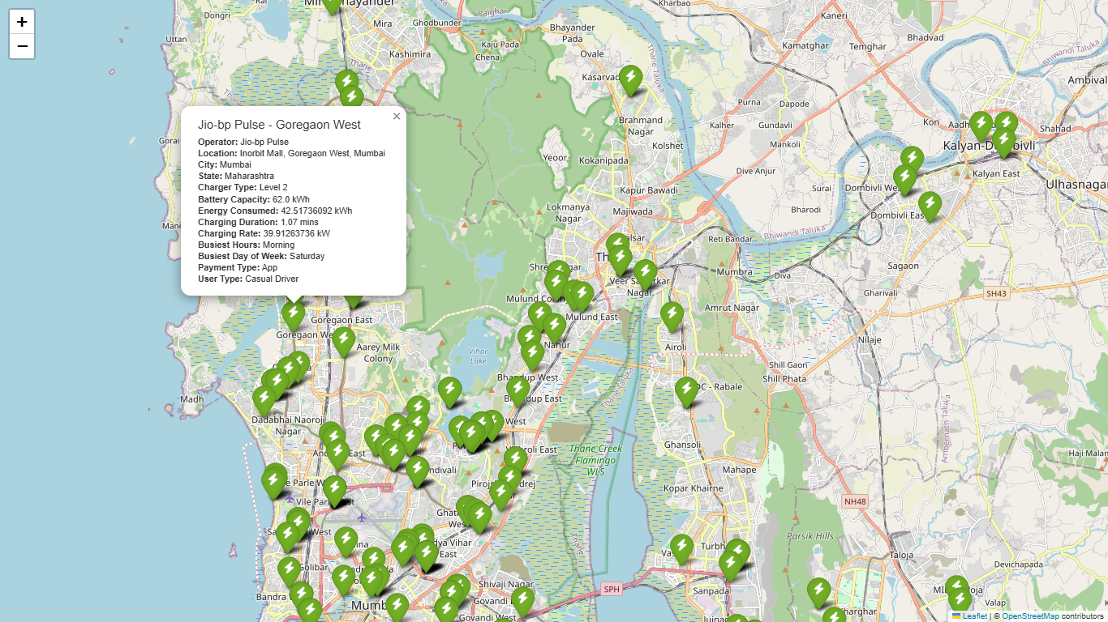

Figure 2. Station Metadata Visualization
Demonstrates the interactive Folium pop-ups that display each station’s details—operator, energy use, and charging time—enabling contextual understanding of site performance and aiding data-driven decision-making.

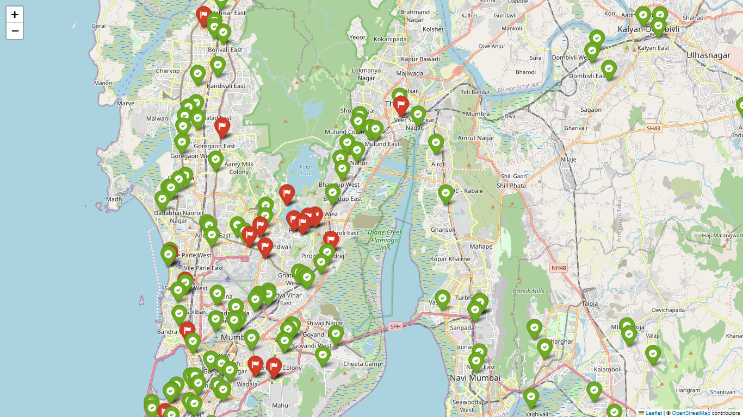
Figure 3. Ridge Regression Predictions
Displays predicted utilization from the Ridge Regression model. Green markers show Existing locations of charging stations, red markers show the predicted new locations suitable for setting up new charging stations, helping identify underperforming or potential new zones.

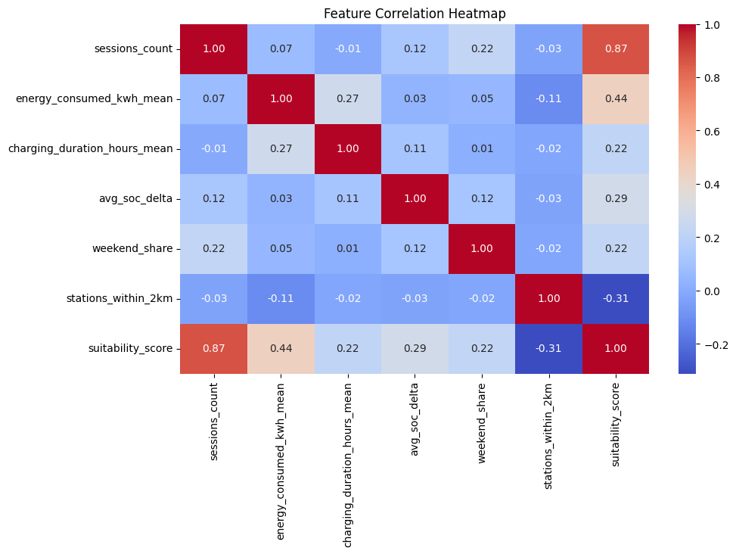
Figure 4. Feature Correlation Heatmap
Shows inter-feature relationships. Strong correlation between session count and energy consumed (0.87) indicates demand–load linkage, while a negative correlation with stations within 2 km (–0.31) suggests that nearby chargers divide usage.

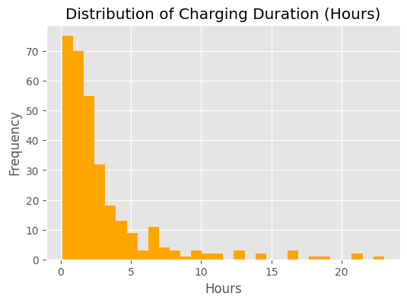
Figure 5. Distribution of Charging Duration
Most sessions last 0–5 hours, indicating short-duration or top-up charging behavior, important for estimating station turnaround and grid load.

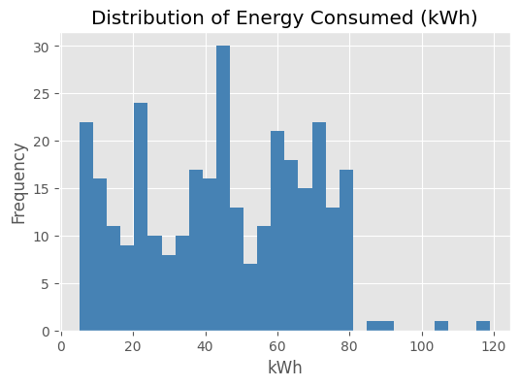
Figure 6. Distribution of Energy Consumption
Energy usage mostly falls between 20–80 kWh, reflecting varied vehicle capacities and mixed charging patterns, validating the need for nonlinear, ensemble-based prediction models.
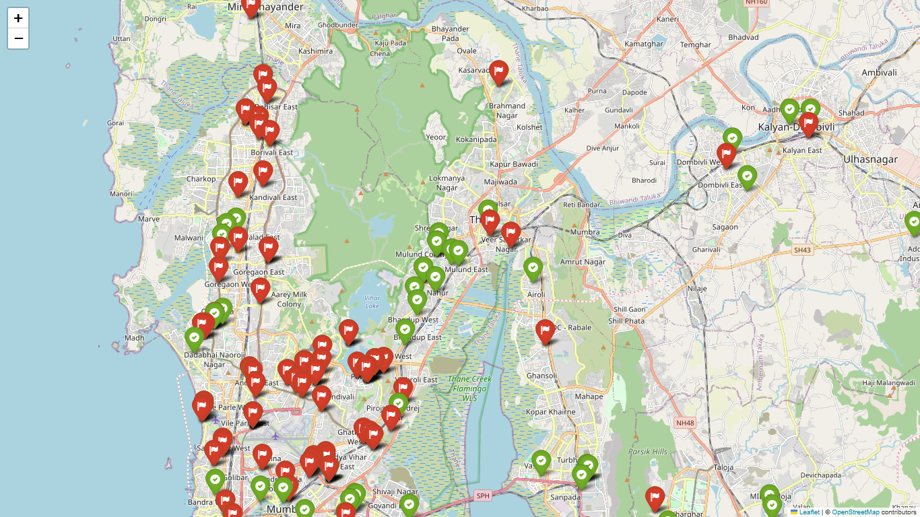
Figure 7 Final Model Predictions after Optimization
Shows final ensemble model outputs (Gradient Boosting, XGBoost). Green markers denote existing stations; red markers highlight recommended new sites such as Andheri East, Bandra West, Thane, and Dadar, confirming accurate hotspot identification after hyperparameter tuning.

Conclusion and future scope

Conclusion
The EVision framework successfully integrates machine learning and geospatial analytics to forecast EV charging demand and recommend optimal site locations across the Mumbai metropolitan region.
Through extensive data preprocessing, feature engineering, and model experimentation, ensemble regressors such as Gradient Boosting and XGBoost achieved an exceptional prediction accuracy of 99.32%, outperforming conventional linear approaches.
Spatial visualization using the Folium library effectively represented both existing and predicted charging stations, providing actionable insights for policymakers, infrastructure developers, and energy providers. The EVision web dashboard, developed with HTML, CSS, and JavaScript, translated these analytical results into an interactive and intuitive visualization tool.
The project demonstrates that data-driven decision support systems can play a pivotal role in achieving India’s sustainable mobility goals by ensuring efficient, well-distributed EV infrastructure deployment. EVision thus bridges the gap between predictive analytics and urban planning, supporting smarter, cleaner, and more accessible transportation ecosystems.

Future scope

While EVision achieves high predictive accuracy and spatial insight, several enhancements can further expand its capabilities:
- Real-Time Data Integration
Incorporate live data streams from IoT-enabled chargers, traffic APIs, and weather sensors to enable dynamic demand forecasting.
- Multi-City Scalability
Extend the system to other metropolitan regions such as Delhi, Bengaluru, and Pune, adapting to diverse demographic and energy profiles.
- Advanced Optimization Techniques
Integrate deep learning models or hybrid algorithms combining spatial regression with time-series forecasting for greater temporal accuracy.
- User-Centric Mobile Application
Develop a public-facing app for EV users to locate nearby stations, view availability, and monitor real-time usage statistics.
- Policy and Energy Grid Integration
Collaborate with municipal authorities and DISCOMs to align EVision’s predictions with grid load balancing and government EV policies.
By expanding along these directions, EVision can evolve into a national-scale intelligent EV infrastructure planning system, guiding India’s transition toward a sustainable, data-driven electric mobility future.

Refernces

[1] K. C. Akshay, G. H. Grace, K. Gunasekaran, and R. Samikannu, “Power consumption prediction for electric vehicle charging stations and forecasting income,” Scientific Reports, vol. 14, no. 6497, pp. 1–15, 2024. DOI: 10.1038/s41598-024-56507-2.
[2] S. Sanami, H. Mosalli, Y. Yang, H.-G. Yeh, and A. G. Aghdam, “Demand forecasting for electric vehicle charging stations using multivariate time-series analysis,” arXiv preprint arXiv:2502.16365, 2025.
[3] T. van Etten, V. Degeler, and D. Luo, “Large-scale forecasting of electric vehicle charging demand using global time series modeling,” in Proc. 10th Int. Conf. Vehicle Technology and Intelligent Transport Systems (VEHITS 2024), pp. 40–51, SCITEPRESS, 2024. DOI: 10.5220/0012555400003702.
[4] M. R. Abdullahi, Q.-C. Lu, A. Hussain, S. Tripura, P.-C. Xu, and S. Wang, “Location optimization of EV charging stations: A custom K-means cluster algorithm approach,” Energy Reports, vol. 12, pp. 5367–5382, Nov. 2024. DOI: 10.1016/j.egyr.2024.09.075.
[5] S. Vyas, S. Balantrapu, S. S. Chavali, and S. Dasgupta, “Optimal siting of charging infrastructure for EV ecosystem partners: A multi-constraint approach integrated with geospatial analysis,” ArcIndia News, vol. 18, pp. 1–8, 2023.
[6] A. Q. Afshar, G. Bouguerra, and B. Layeb, “Optimal siting and power consumption prediction for electric vehicle charging infrastructure,” World Electric Vehicle Journal, vol. 15, no. 31, pp. 1–12, 2024.

